TOPIC 11: Forensics

Worksheet 11.2

If the boot fits
Answers
Forensic scientists work together to investigate and make a deduction based on evidence provided. You will use the photograph of the bloody footprint which is evidence in the ‘Coffee shop shoot out’ case.
The ability to observe every detail at a crime scene is one of the most important skills a forensic scientist has. The evidence could be as large as the body of a victim or as small as the DNA attached to a single strand of hair from the suspect. All of the evidence, no matter how big or small, can be used to piece together what occurred at the crime scene.
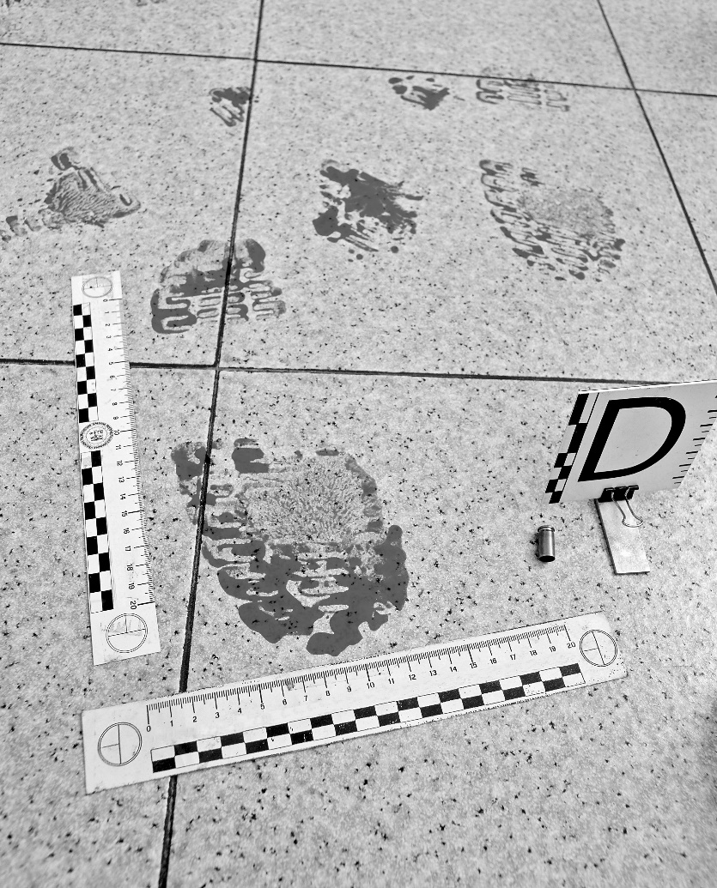
Imagine that you are a forensic scientist at the ‘Coffee shop shoot out’ crime scene. You have been sent by the senior forensics scientist to investigate the bloodied footprint. Examine the evidence and complete the following questions.
© Photolibrary/SPL/Mauro Fermariello
1. How fast was the person moving? What evidence did you use to decide on the answer?
Slowly. The footprint is pressed firmly into the ground.

3. What is the size of the footprint? What size shoe could this be?
Large. Size 12.

4. What type of shoe has left the footprint? How can you tell?
The tread mark indicates a workboot.

5. Is the footprint close to or far away from the source of the blood? How did you decide on your answer?
Because of the amount of blood on the tread, it could be deduced that the source of blood is close.

6. Does the footprint belong to a male or female? Explain.
Male or female. This type of shoe is worn by many people. The foot size indicates it’s most likely a male.

Extension
How can a footprint provide other evidence depending on what substance the print is left in?
Dirt or pollen embedded in the tread may be left at the crime scene. If left in soft material, such as sand, the wearer’s weight may be deduced.

